AI ASSIGNMENT - 7.3
TASK 1: Paste a function with a missing colon (add(a, b)), and let AI fix the syntax error
Error code:
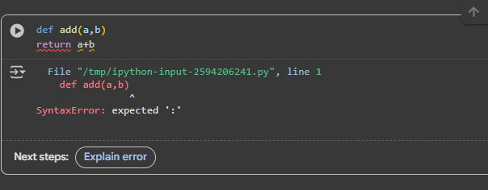
Corrected code and explanation:
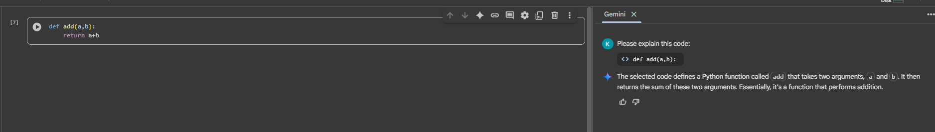

TASK 2: Identify and fix a logic error in a loop that causes infinite iteration
Error code:
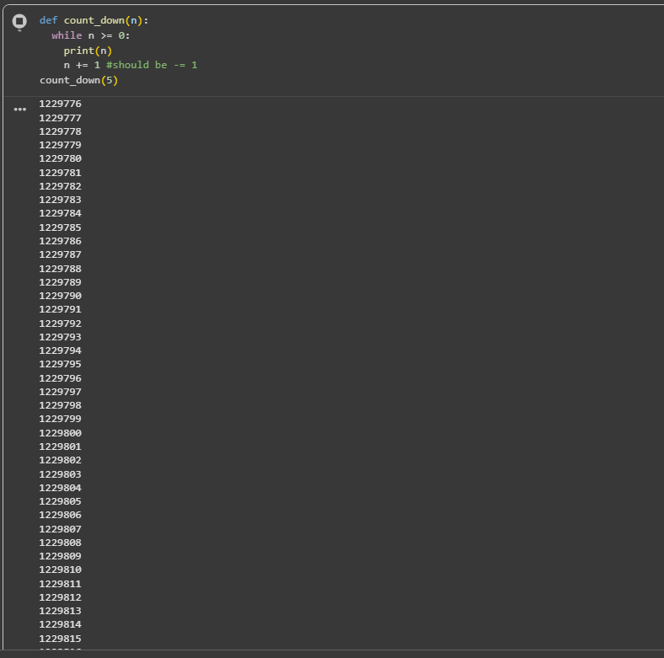
Corrected code and explanation:
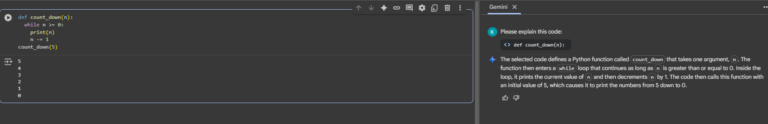
TASK 3: Debug a runtime error caused by division by zero. Let AI insert try-except
Error code:
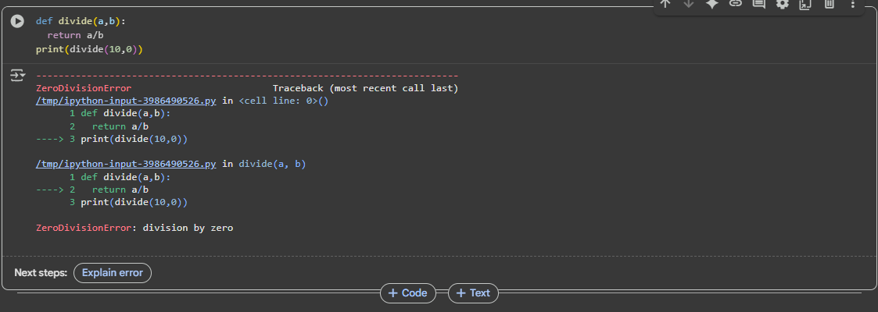
Corrected code and explanation:
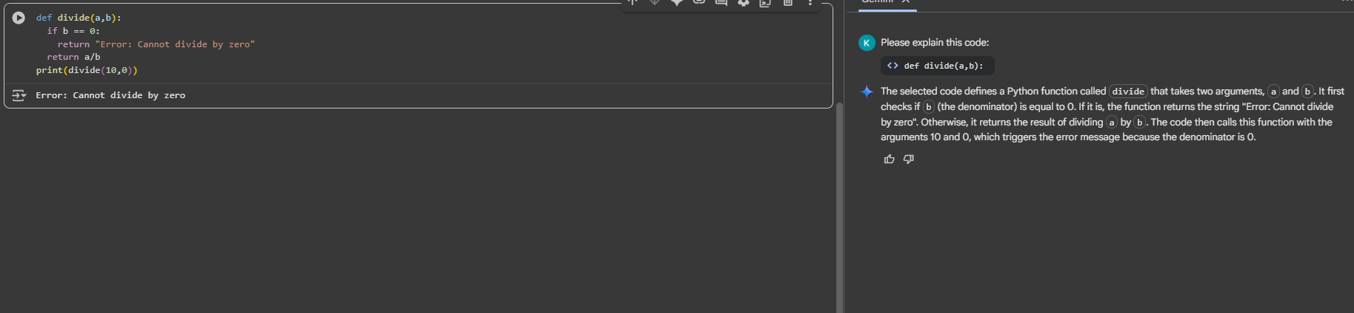
TASK 4: Provide a faulty class definition (missing self in parameters). Let AI fix it
Error code:
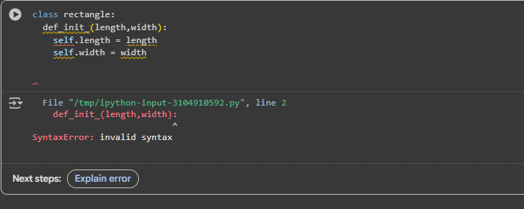

Corrected code and explanation:
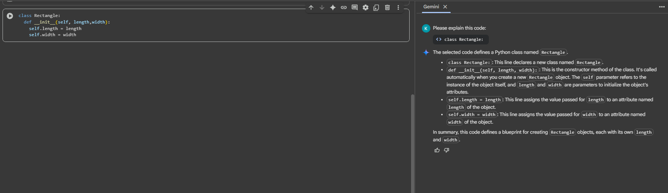
TASK 5: Access an invalid list index and use AI to resolve the Index Error.
Error code:
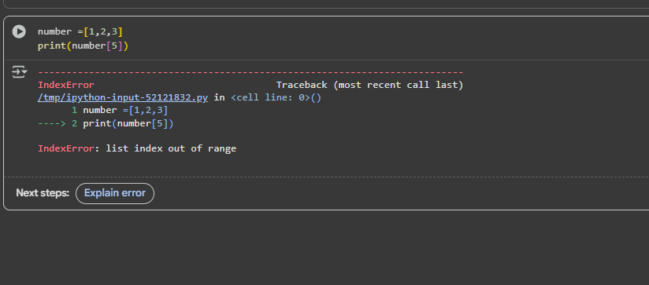
Corrected code and explanation:
